**Git Hub VS AWS Code Commit**

|  |  |  |
| --- | --- | --- |
| **Parameters** | **AWS Code Commit** | **Git Hub** |
| Owner | Amazon | Microsoft |
| Launched | 2008 | 2015 |
| Definition | AWS Code Commit is a fully structured, elastic source control system that provides secure Git-based storehouse services or repositories. AWS Code Commit is a version control system maintained by AWS to secretly store and maintain assets in the cloud and merge with AWS. | GitHub is a pure code-derived source for version control for developers to work together and also linked together on projects. When many people work together on a project, it becomes very difficult to trace changes and this encourages the possibility of overwriting each other's changes. |
| Deployment | Saas | Saas |
| User Interface | Code Commit’s user interface is pretty average | GitHub is fully featured and has a ***really nice UI*** |
| Storage Limit | AWS CodeCommit does ***not have any limit on file type and file size***. Hence you can store the n number of any file. | While GitHub put a limitation on the size of files. It allows you to store files of size less than 100MB. If you exceed the maximum file storage limit, it pushes blocks to the repository. |
| Security | CodeCommit uses AWS’s IAM Roles and users. This makes it highly secure. Using IAM roles lets you share your repositories with only specific people while letting you limit their access to the repository. For example, few users can view the repository, few people can make edits, etc | Git is administered using GitHub users. Improved security; offer private repositories |
| code review | We can do Code review interms of Pull request. | On GitHub, lightweight code review tools are built into every pull request. Your team can create review processes that improve the quality of your code and fit neatly into your workflow. |
| Scalable | CodeCommit is designed to handle the scalability needs of enterprises, and its performance can scale effectively as your code base and team grow. | It offers ***excellent scalability*** for hosting source code repositories and handles the load efficiently. |
| interoperability | Both platforms have strong interoperability with Git, making it possible to move code between them relatively easily if needed. | |
| Price | Anyone with an AWS account can get started with AWS CodeCommit for free. The Free Tier includes 5 active users, 50 GB-month of storage and 10,000 Git requests per month. | GitHub is free for teams, offering them access to unlimited private repo’s with unlimited collaborators free of cost. The paid plans start at $4 per user per month for GitHub Team and go up to $21 per user per month for the Enterprise plan |
| Companies | JPMorgon Chase, Salesforce, Delta Air Lines | Airbnb, Netflix, Shopify |
| Integration with Selenium | If you are developing your Selenium test scripts and related code in AWS infrastructure and want seamless integration with other AWS services , CodeCommit can be a suitable choice. CodeCommit offers secure, scalable, and reliable version control for your code, including test scripts. | On the other hand, if you value community collaboration and platform independence, GitHub can be a more suitable choice. |
| Integration with Sonar Qube | If your organization is primarily using AWS services and has a significant presence on AWS, using SonarQube with CodeCommit can provide better integration with your AWS infrastructure. | Independence from cloud providers: If your organization is not tied to a specific cloud provider or primarily uses GitHub as a central code repository, integrating SonarQube with GitHub makes more sense. |

**Price chat for Code Commit:-**

Ref link - <https://aws.amazon.com/codecommit/pricing/>

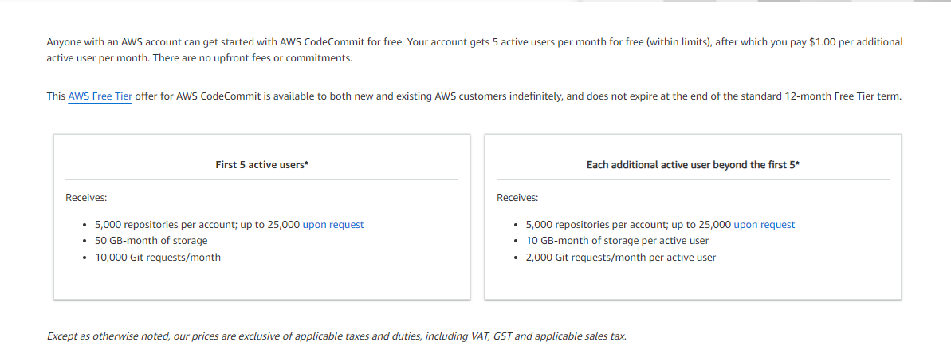

**Price chat for Git Hub:-**

Ref link - https://github.com/pricing

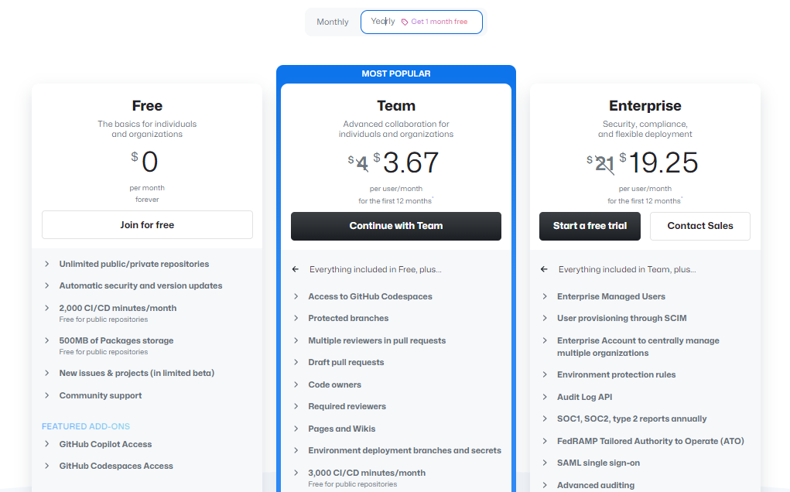

**Integration of Git Hub with AWS Code Build:**

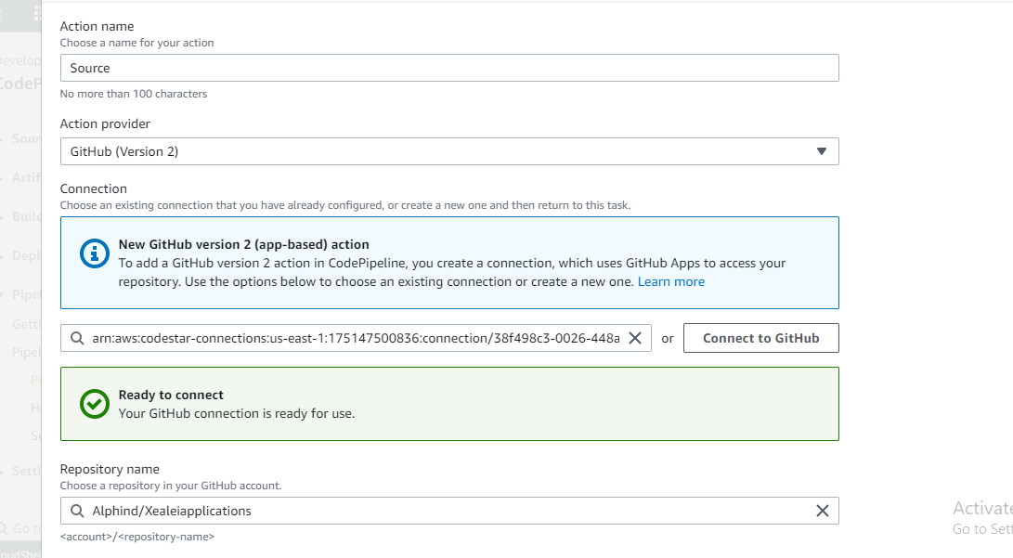

**Reference Links:**

<https://appwrk.com/aws-codecommit-vs-github>

<https://appwrk.com/aws-codecommit-vs-github>

<https://www.ap2v.com/blog/aws-code-commit-vs-github>